To: Mrs. This Is-An-Example
From: Dr. Durant
Subject: The Very Important Project
Date: 5/28/20

Executive Summary
Professional reports start with an executive summary but you should absolutely write this last (sometimes you may want to boldface or italicize font within sections to emphasize a point). These typically start with a clear thesis statement – what is the purpose of the document – and then summarize all the main findings. This is sometimes the only section some people have time to read. Therefore, it should be clear, concise, and comprehensive of all your findings and recommendations. It would be difficult for you to summarize your main findings and recommendations if you have not written them yet, which is why I strongly recommend saving this section for the end.

This is a Descriptive Section Heading for the First Section
After the executive summary, you move into the body of the paper. Each section of the body should have a descriptive section heading that lets the reader know what will be covered in that section. Sections can be a single paragraph or a collection of paragraphs. It will depend on how you want to organize your work. Remember, there should be no mention of the case, the course, or specific questions in the assignment; you will want to answer everything but in a narrative/story-telling format from the role-playing perspective of a business professional.

This is Another Descriptive Section Heading for the Next Section
You should have section headings where it makes sense in terms of how best to organize and group the information. Having descriptive section headings makes it so you can rely less on written transitions in the narrative. You will have as many sections as you believe are necessary to get the job done. Here are some reasons I like section headings:
- They make your work scannable—someone with limited time could read your executive summary and section headings and get a good sense of what will be covered in your paper
- They make it easier for me to grade—I have a checklist of all the items I am looking for and I start by scanning your paper to try and locate each of those items before I read it in detail
- They add professionalism—boldface section headings make the paper look visually pleasing
- When making a number of similar points or listing information, use of bullets and numbered lists can help in making your work scannable, as you see in this example

You also want to make sure that you included all of your supporting visuals in an Appendix and refer to them in the text. For example, for more information on Social Determinants of Health, please see Figure 1 of the Appendix. These are often in boldface font to make them stand out. Anything provided in the Appendix MUST be mentioned in the text. There are very important notes on paragraphing in Table 1 of the Appendix; please read those. Other examples of professional tables are provided as Table 2 and Table 3 of the Appendix.

This is Another Descriptive Section Heading for the Final Section
While this paper only has three sections, your paper should have as many as you feel are necessary to appropriately organize your work. Make sure all outside sources (if necessary) are cited in-text and in full form in a reference list. One way to do this is by going to “References” and selecting the “Insert Endnote” option. Here is another example of how this looks in-text. To change the numbering format of your endnotes, open the full “Footnotes” menu and you should see an option to “Change Number Format.”

Conclusion
A conclusion is a nice way to summarize for your reader all the main points of the paper. This should reflect the executive summary but not repeat it verbatim. It is often only a few sentences, but it wraps your paper up in a nice bow. Here is where you get to emphasize the points you really want your reader to walk away with. Hey, one last thing, did you notice that this paper has page numbers? No? Well, those are really important. Include them.
Appendix

Figure 1: Descriptive Title of Figure
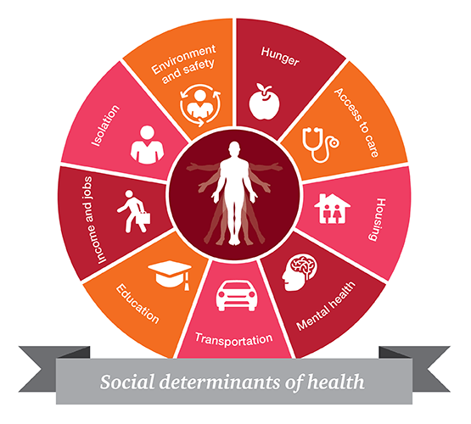
Table 1: Notes on Paragraphing
A paragraph is a collection of related sentences dealing with a single topic…
To be effective, a paragraph must have:
- Unity
  - A topic sentence & adequate development
UNITY: Basic rule of thumb: Keep one idea to one paragraph
- The entire paragraph should concern itself with a single focus
TOPIC SENTENCE: A topic sentence is a sentence that indicates in a general way what idea or thesis the paragraph is going to deal with. An easy way to make sure your reader understands the topic of the paragraph is to put your topic sentence near the beginning of the paragraph.
ADEQUATE DEVELOPMENT:
- The topic (which is introduced by the topic sentence) should be discussed fully and adequately.
- Some methods to make sure your paragraph is well-developed:
  - Use examples and illustrations
  - Cite data (facts, statistics, evidence, details, and others)
  - Examine testimony (what other people say such as quotes and paraphrases)
  - Use an anecdote or story
  - Define terms in the paragraph
  - Compare and contrast
  - Evaluate causes and reasons
  - Examine effects and consequences
  - Analyze the topic
  - Describe the topic
  - Offer a chronology of an event (time segments)
EXAMPLES: What’s Wrong with this?
Increasing rates of obesity among adults and children is an important policy issue in the United States. Rates of adult obesity in the United States have increased significantly over the last few years, with a similar pattern among children. These rates have skyrocketed across the country, which makes them a serious public health issue. Public health becomes a concern when rates of obesity are as high as in the United States.
EXAMPLES: How is this better?
Growing rates of obesity in children and adults is a serious public health issue in the United States. Rates of adult obesity in the United States have doubled since the 1970s, with rates of childhood obesity tripling across the same time period (Yang & Nichols, 2011). As of 2010, 35.9% of adults over the age of 20 were obese, with rates of overweight and obese at 69.2%. In children and adolescents, the rate of obesity is 18% (CDC, 2010). As a person’s body mass increases, so does their risk for coronary artery disease, stroke, type II diabetes, and a variety of other chronic health conditions (CDC, 2012).

Table 2: Descriptive Title of Table
Number of Pets | Number of Cats | Number of Dogs
5 | 5 | 0
23 | 13 | 10

Table 3: Descriptive Title of Table
Name | DOB | Occupation | Salary | Marital Status
Tom Thomas | 8/9/1985 | Dragon Slayer | $44,111 | Married
Dan Daniels | 7/12/1989 | Blacksmith | $22,333 | Divorced
Marge Martin | 12/23/1990 | Plague Doctor | $999,888 | On Tinder
Will Williams | 02/10/1972 | Cobbler | $120,666 | Very Alone

References

Example reference – use any style you want but I suggest APA
Example reference number 2
Example reference number 3; there is no threshold for number of references you need – use however many gets the job done

